Instruction Manual for Microprocessor Centrifuge DSC-302SMD (DC brushless motor)
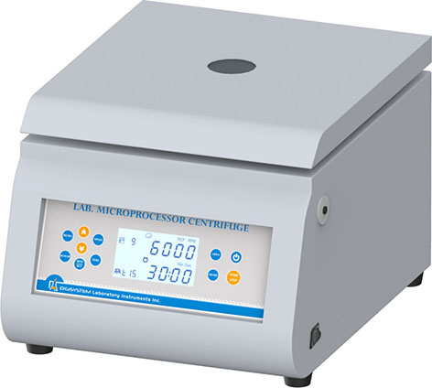
Lid

Emergency device


Main power switch
Emergency bar

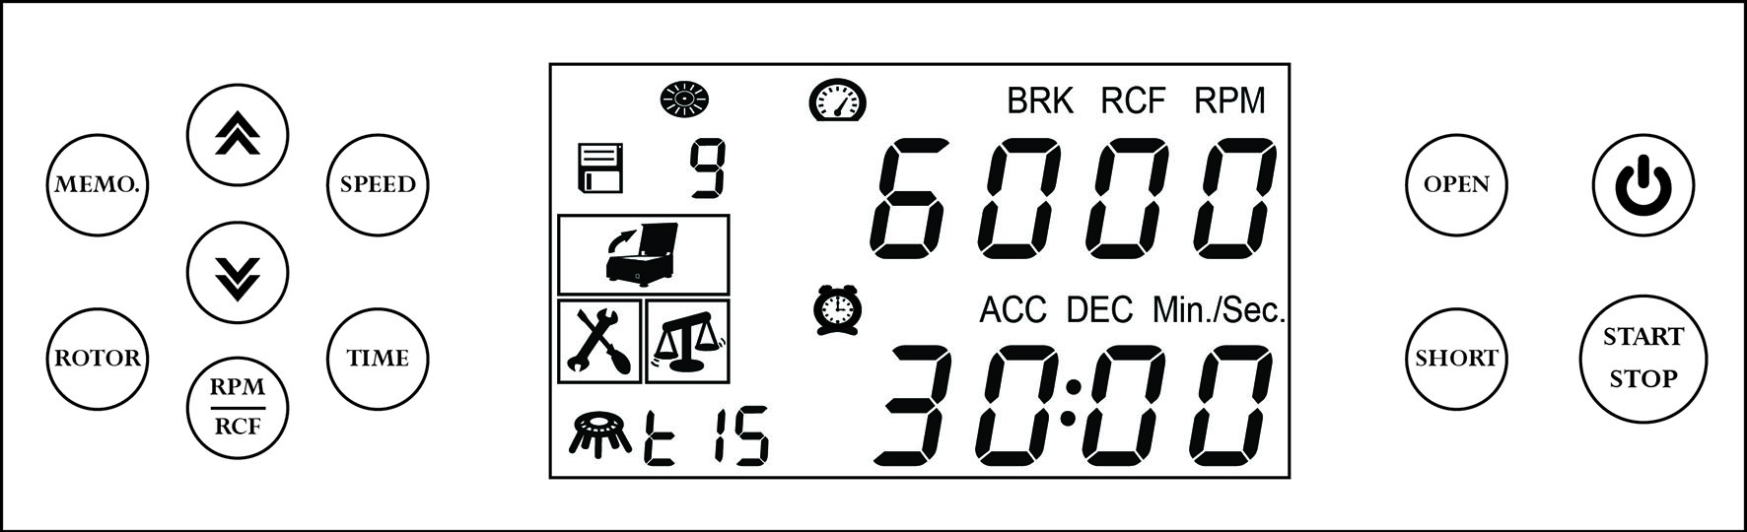

Warnings:
* Do not open the lid before the centrifuge stops completely.
* Do not remove the centrifuge during operation.
* Do not put objects on the top of the lid.
* Do not disassemble the centrifuge by yourself. In the event of a malfunction, the centrifuge should be repaired by a qualified technician. Before repairing, turn off the power.
Steps:
- Place the centrifuge on a flat surface. Plug the centrifuge into a properly grounded outlet. Turn on the main power switch on the right side of the centrifuge.
- Push the button , and then the screen is illuminated. Press the button to open the lid. The icon is flash on the screen. Insert an even number of tubes in a symmetrical position into the rotor.
- Put down and press down the lid. Make sure the lid is closed well. The icon will disappear on the screen.
- Push the button , the speed value is flash one the screen. Push the button or to set the speed value. Push the button or any other function button to enter the speed value.
- If you want to set RCF value instead of setting Speed value, please push the button and then push the button . The icon RCF will appear on the screen, and the RCF value is flash on the screen. Push the button or to set RCF value. Push the button or any other function button to enter the RCF value.
- Push the button , the time value is flash on the screen. Push the button or to set seconds. Push again to set minutes. Push the button or any other function button to enter the time value.
- Push the button . The rotor type value is flash. Push or to set rotor type (refer to the below table. ) Push the button again. The tube adapter size value is flash. Push the button or to choose the tube adapter size. Push the button to enter the rotor value.

Rotor type | Rotor type on the screen | Tube adapter size
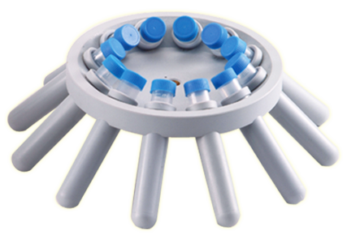 AR-1512 |  | 2ml, 7ml, 15ml
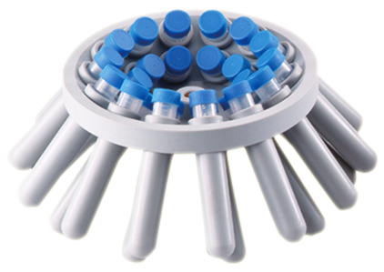AR-1524 |  | 2ml, 7ml, 15ml
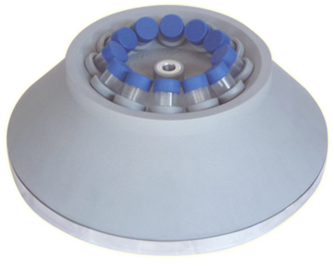UAR-1512 |  | 2ml, 7ml, 15ml
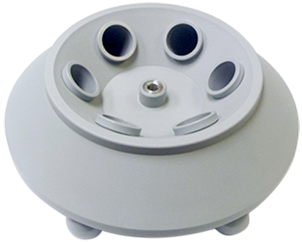AR-5006 |  | 50ml
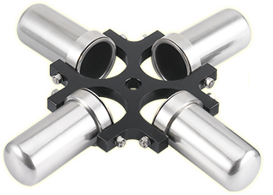SB071550 |  | 7ml, 15ml, 50ml
- After setting parameters, push the button to start the centrifuge. During operation, push the button to stop the centrifuge.
- Push the button to start the centrifuge directly. Release the button and the centrifuge will stop immediately. The centrifuge will run to the current speed setting value.

- Brake setting: the initial setting is auto brake and the screen will show BRK. If you want to cancel the auto brake function (which means when the machine stop rotating, there is no auto brake function, and the machine will stop rotating naturally.) Push the button continuously, and at the same time, push the button ，the BRK will disappear. Repeat the same step, the auto brake function can restore.
- Using memory program setting:
11.1 How to use memory program: push the button , the icon is flash on the screen. Push the button or to choose the memory number 1,2,3, …, 9. Then, push the button to start the centrifuge
11.2 Parameter setting: Push the button , the icon is flash on the screen. Push the button
or to choose the memory number 1,2,3, …, 9. Push the button to set the speed value. Push the button to set the time value. Push the button to set rot and tube adapter size. Push the button to finish the memory setting.
10.3 How to exit the memory mode: Push the button . Push the button or , until there is no number beside the icon . (Note: Another way to exit the memory mode. Push the button to turn off the power, and then push the button again to exit the memory mode.)
12. Under the conditions of power failure or the open function failure, please insert the “Emergency Bar” into the hole at right hand side of centrifuge to force the lid open.
Other functions: (Under no operation condition, it can execute other functions.)
- Adjust the contrast of the characters on the screen:
1.1 Push the button , and do not release. At the same time push the button to increase the contrast. The icon ACC is flash on the screen.
1.2 Push the button , and do not release. At the same time push the button to decrease the contrast. The icon DEC is flash on the screen.
- Adjust the brightness of the background of the screen:
  - Push the button , and do not release. At the same time push the button to increase the brightness. The icon ACC is flash on the screen.
  - Push the button , and do not release. At the same time push the button to decrease the brightness. The icon DEC is flash on the screen.
Maintenance and care:
- Keep the centrifuge clean all the time. Cleaning can be done with a damp cloth. Avoid the use of solvents as they may damage the product housing, rotor.
- Check if the rotor is in the center. In case, the rotor is slanted. Stop using machine and contact the distributor for repair.

Circuit Diagram:
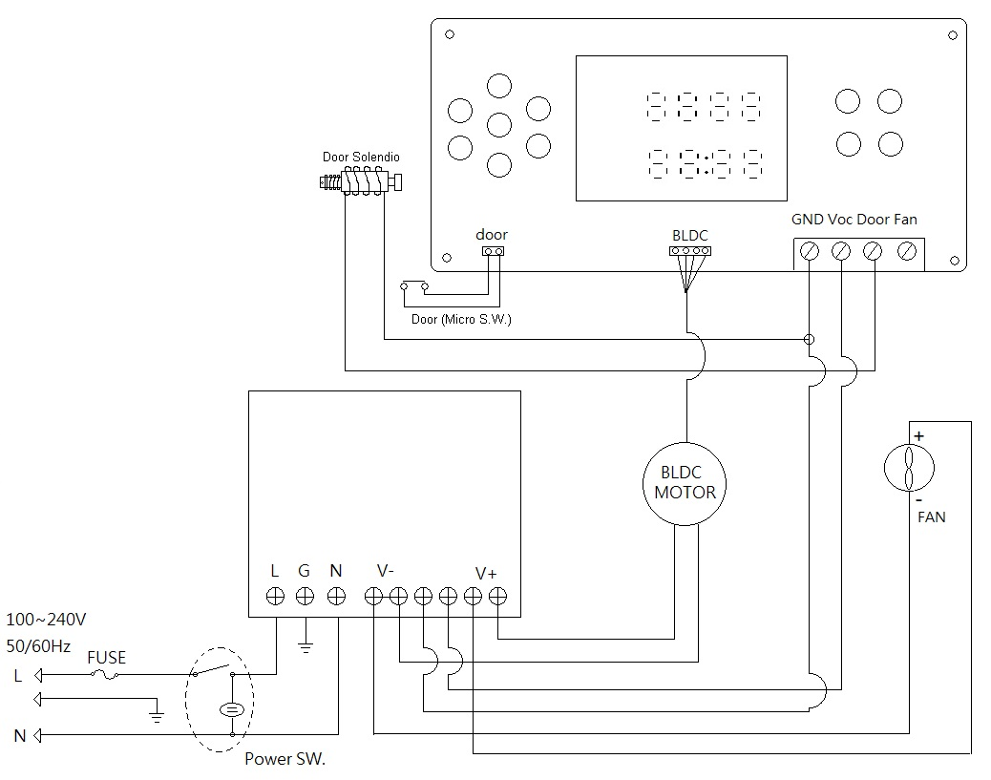

Service Manual

Troubleshooting Guide
Caution: Always disconnect the power cord before troubleshooting.
Trouble / error message | Cause | Remedy
Motor is not working | - Rotor type setting is not correct.  - Foreign bodies block the motor.  - Motor is defective. | Turn the main power switch off, and then turn it on again.  - Please check and re-set the rotor.  - Sweep away foreign bodies.  - Contract the distributor for repair.
Over heat | - Rotor type setting is not correct.  - Over time use.  - Motor is defective. | Turn the main power switch off, and then turn it on again.  - Please check and re-set the rotor.  - Stop using to let the centrifuge cool down. And then restart it.  - Contract the distributor for repair.
Over current | - Rotor type setting is not correct.  - Rotor is overloaded。  - Motor is defective. | Turn the main power switch off, and then turn it on again.  - Please check and re-set the rotor.  - Reduce the loading on the rotor.  - Contract the distributor for repair.
Over voltage | - Rotor type setting is not correct.  - Switching power is defective. | Turn the main power switch off, and then turn it on again.  - Please check and re-set the rotor.  - Contract the distributor for repair.
 | - When the motor is rotating, push the button . | - Waiting for motor stop completely, and then push the button , and then close the lid to restart the centrifuge.
Unbalance | - Rotor is unbalanced.  - The surface which the centrifuge is on is not flat. | - Open the lid and set the rotor to be balanced.  - Place the centrifuge on a flat surface.
Lid open error | - During operation, the lid is open. | - Waiting for the motor stop completely. And close the lid.
Speed error | - Rotor type setting is not correct.  - Motor, PC board, or switching power is defective, so the speed can’t reach to the setting value. | - Open the lid. Check and reset the rotor.  - Contract the distributor for repair.
No display on the screen | - Power is off.  - Dead power output。  - Burnt fuse  - PC board is defective. | - Turn on the power.  - Change to a different output.  - Replace a new fuse.  - Contract the distributor for repair.
Burnt fuse | - Fuse is wasted  - Switching power is defective. | - Replace a new fuse.  - Contract the distributor for repair.
Lid can’t be open | - Lid lock is defective.  - PC board is defective.  - PC board is crashed. | - Contract the distributor for repair.  - Contract the distributor for repair.  - Turn off the main power switch , and turn on the power again.
Noise is too loud. | - Rotor is unbalanced.  - Rotor type setting is not correct. | - Stop the machine. Open the lid and set the rotor to be balanced.  - Please check and re-set the rotor.
Note: To clear the error message , , , , turn the main power switch off, and turn on it again.
For the other error messages, push the button to clear them.

